LUCY MAGOMA OBARE

Code Understanding Journal
Java Task Manager
WeThinkCode AI Course Exercise
April 2026

Entry 1 — Application Overview
Source: README.md

The Task Manager is a command-line Java application that allows users to manage tasks. It supports creating tasks with a title, description, priority, due date and tags. Users can update task status, priority and due dates, add or remove tags, view task details and see overall statistics. The app is built using Gradle as its build tool.

Available Commands
Command | What It Does
create | Create a new task with title, description, priority, due date and tags
list | List all tasks, with optional filters by status or priority
status | Update a task's status (e.g. todo → done)
priority | Change the priority level of a task
due | Update the due date of a task
tag / untag | Add or remove labels from a task
show | Display full details of a single task
delete | Permanently remove a task
stats | Show a summary of all tasks by status and priority

Entry 2 — File Structure Overview

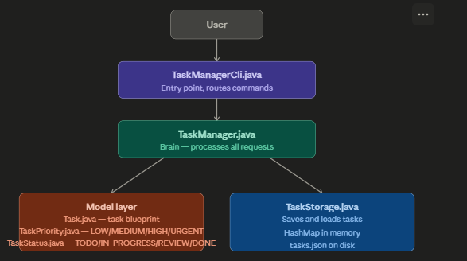
Source: VS Code left panel exploration

The project has 6 main Java files organized into 4 packages. I initially expected 9 files based on my first exploration, but discovered that some files (TaskPriorityManager, TaskMergeService, TaskParser) do not yet exist — the README confirms the repo is still a work in progress.

File | Package | What I Think It Does
TaskManagerCli.java | cli | Entry point — reads user commands and routes them
TaskManager.java | app | Brain of the app — processes all requests
Task.java | model | Blueprint of a task — defines all its properties
TaskPriority.java | model | Defines priority levels: LOW, MEDIUM, HIGH, URGENT
TaskStatus.java | model | Defines status levels: TODO, IN_PROGRESS, REVIEW, DONE
TaskStorage.java | storage | Saves and loads tasks to a JSON file on disk
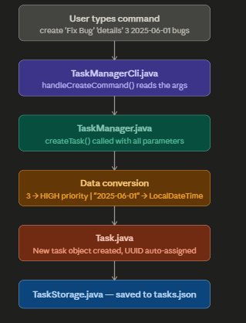

Entry 3 — Task.java (Model Layer)
Source: src/main/java/za/co/wethinkcode/taskmanager/model/Task.java

What I discovered
Task.java is the data blueprint for the application. Every task automatically receives a unique UUID when created and defaults to TODO status. The class provides three constructors for flexibility — you can create a task with just a title, or with full details.
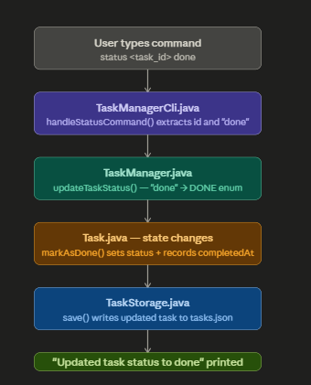

Key properties of every task
- id — unique UUID automatically generated (no manual input needed)
- title, description — basic task information
- priority — TaskPriority enum (defaults to MEDIUM)
- status — TaskStatus enum (always starts as TODO)
- createdAt, updatedAt, dueDate, completedAt — timestamps
- tags — a List of String labels

Interesting design pattern discovered
Constructor Overloading — three constructors allow flexible task creation. The simpler versions automatically fill in sensible defaults (MEDIUM priority, no due date).

Important business methods
- update() — only updates fields that are actually provided, leaves everything else unchanged
- markAsDone() — automatically records the completion timestamp when called
- isOverdue() — checks if the due date has passed and the task is not yet DONE

Entry 4 — TaskManager.java (App Layer)
Source: src/main/java/za/co/wethinkcode/taskmanager/app/TaskManager.java

What I discovered
TaskManager.java is the coordinator of the application. It never stores data directly — it always delegates saving and loading to TaskStorage. This separation keeps the code clean and organized.

Execution flow when creating a task
- 1. createTask() receives title, description, priority number, date string and tags
- 2. Priority number is converted to a TaskPriority enum (e.g. 3 → HIGH)
- 3. Date string is parsed to a LocalDateTime object (e.g. 2025-06-01 → midnight of that day)
- 4. A new Task object is created with all the details
- 5. TaskStorage.addTask() saves it and returns the new task ID

Interesting design pattern discovered
Delegation Pattern — TaskManager never handles data directly. Every operation ends with a call to getStorage(). This separates responsibilities cleanly between processing and storage.

Notable observation
When a task status is changed to DONE, the code automatically calls markAsDone() to record the completion timestamp. The user does not need to do anything extra.

Entry 5 — TaskStorage.java (Storage Layer)
Source: src/main/java/za/co/wethinkcode/taskmanager/storage/TaskStorage.java

How data is stored and retrieved
Tasks are kept in a HashMap in memory while the app is running, with the task ID as the key for instant lookup. Every time any change is made, the entire map is written to a tasks.json file on disk using the Gson library.

Key methods
- load() — reads tasks.json when the app starts and fills the HashMap
- save() — writes the entire HashMap to tasks.json after every single change
- addTask() — adds to HashMap then calls save()
- getTasksByStatus() / getTasksByPriority() — uses Java Streams to filter tasks

Interesting design pattern discovered
Repository Pattern — TaskStorage acts as a clean interface hiding all file reading and writing complexity from the rest of the app. The rest of the code never needs to know about JSON or file paths.

Notable observation
Java dates (LocalDateTime) cannot be saved to JSON automatically. TaskStorage includes two custom inner classes — LocalDateTimeSerializer and LocalDateTimeDeserializer — to handle this conversion. This is a practical solution to a real Java limitation.

Entry 6 — Priority System (Part 2)

My initial understanding (before reading the code)
- I expected 3 priority levels: LOW, MEDIUM, HIGH
- I thought priorities would be stored as plain text strings
- I assumed a separate TaskPriorityManager.java file existed
- 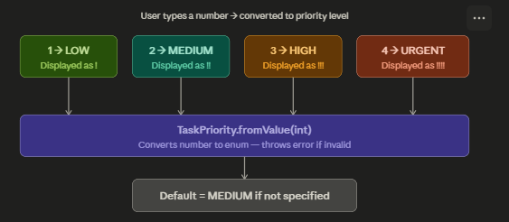

What I actually discovered
- There are 4 priority levels — URGENT was a surprise addition
- Priorities are stored as enums with number values attached (1=LOW, 4=URGENT)
- TaskPriorityManager.java does not exist — priority logic is inside TaskManager.java
- Default priority is MEDIUM (value 2) when the user does not specify one

Number | Priority | Display | Default?
1 | LOW | ! | No
2 | MEDIUM | !! | Yes
3 | HIGH | !!! | No
4 | URGENT | !!!! | No

Entry 7 — Task Status System

TaskStatus.java defines 4 statuses that represent the full lifecycle of a task. Unlike TaskPriority which uses numbers, statuses use text strings for lookup.

Status | String Value | Meaning
TODO | todo | Task created but not yet started
IN_PROGRESS | in_progress | Currently being worked on
REVIEW | review | Done but waiting for review
DONE | done | Fully completed

The 4 statuses mirror a real software development workflow: TODO → IN_PROGRESS → REVIEW → DONE. Every new task starts as TODO automatically.

Entry 8 — TaskManagerCli.java (CLI Layer)
Source: src/main/java/za/co/wethinkcode/taskmanager/cli/TaskManagerCli.java

TaskManagerCli is the entry point and user-facing interface of the application. It receives typed commands, routes them using a switch statement to specific handler methods, which then call TaskManager methods.

Interesting things noticed
- Default values — priority defaults to MEDIUM (2) if the user does not specify one
- Tags support comma separation — typing bugs,frontend automatically creates two tags
- Short ID display — UUIDs are long so only the first 8 characters are shown
- Visual symbols for status — [ ] for TODO, [>] for IN_PROGRESS, [?] for REVIEW, [checkmark] for DONE
- Visual symbols for priority — more exclamation marks means higher urgency

Command Pattern — each user command maps directly to its own dedicated handler method, keeping the code organized and easy to extend with new commands in future.

Entry 9 — Data Flow: Marking a Task Complete (Part 3)

The following describes exactly what happens inside the application when a user types the command to mark a task as done.

Step-by-step data flow
- 1. User types: status <task_id> done
- 2. TaskManagerCli — handleStatusCommand() extracts the task ID and the string 'done'
- 3. TaskManager — updateTaskStatus() is called with these two values
- 4. TaskStatus.fromValue('done') converts the string to the DONE enum
- 5. Task.markAsDone() is called — status is set to DONE and completedAt timestamp is recorded
- 6. TaskStorage.save() writes the updated task to tasks.json on disk
- 7. 'Updated task status to done' is printed to the user

State changes that occur
- status field changes from previous value → DONE
- completedAt field changes from null → current date and time
- updatedAt field is also updated to the same timestamp

Potential points of failure
- Invalid task ID — task not found in HashMap, returns false with an error message
- Invalid status string — TaskStatus.fromValue() throws IllegalArgumentException
- File write error — IOException if tasks.json cannot be written (disk full, permissions)

How the app persists these changes
TaskStorage saves the entire HashMap to tasks.json after every change. The Gson library converts each Task object to JSON, including all updated timestamps. On next startup, load() reads this file and restores the full state.

Entry 10 — Reflection (Part 4)

What I found most challenging
Tracing how data flows across multiple files. It was not immediately obvious that TaskManager never stores data itself — it always delegates to TaskStorage. Understanding this delegation pattern was the key to understanding the whole application.

Misconceptions I had
- Expected 9 files — only 6 actually exist. The repo is still a work in progress.
- Expected TaskPriorityManager.java to exist — priority logic is inside TaskManager.java
- Expected 3 priority levels — the code has 4 (URGENT was not anticipated)
- Expected priorities to use text strings like status does — they actually use numbers

Most effective prompt strategy
Pasting one complete file at a time and asking 'what does this do and how does it connect to the rest of the app' gave the clearest and most useful answers.

Design patterns discovered
- Delegation Pattern — TaskManager delegates all data operations to TaskStorage
- Repository Pattern — TaskStorage hides all file I/O behind a clean interface
- Command Pattern — TaskManagerCli uses a switch statement to route each command to its own handler method
- Constructor Overloading — Task.java provides 3 constructors for flexible task creation

Most interesting discovery
TaskStorage calls save() after every single modification — addTask, updateTask, deleteTask, addTag, removeTag — all trigger an immediate file write. This means no data can ever be lost even if the application crashes unexpectedly. It is a simple but very effective design choice.

